GroupGo

User Stories and Diagrams

## Part 1: Summary

Stakeholders: Any size group of travelers, Travel Agents, Event Coordinators, Content Creators

Summary: Main Customer need and how the app meets it.

GroupGo is a travel coordinator app that helps groups of people, coordinate and plan travel. This application will assist users who want to travel in a group by utilizing Artificial Intelligence that will take in each person’s set preferences (travel days, budget, activities, and preferred method of travel). Once each user has submitted their preferences, the LLM will develop an itinerary based on each user’s input. Data will be populated by using multiple APIs such as Duffel, Open-Meteo, Google Places and Foursqure.

The Duffel API will help provide flight and hotel information as well as prices for each. Open-Meteo will provide weather information and forecast predictions to help users select activities on their itinerary. Google Places along with the Foursqure API will assist with providing additional hotel stays and attraction information users can select to add to their prospective travel plans.

## Part 2: User Stories

Feature: Finding Flights

As a user, I want to find flights for my trip so that I can compare prices and options easily that are within my budget.

Specific: Find flights that are within my given budget.

Measurable: The system should return a minimum of 3 flight options that don’t exceed my budget input.

Achievable: This can be implemented using Duffel API

Relevant: It helps me select a flight that is within their budget for my intended trip.

Timeboxed: This feature should be completed by the end of sprint 1.

Feature: Finding a hotel in the date range based on the budget.

As a user, I want to find a hotel within my budget for the specified date range so that I can stay comfortably.

Specific: Find hotels with ratings that are within my budget

Measurable: The search should return at least 3 hotel options within my budget.

Achievable: This can be developed using the Duffel, Google Places, and Foursquare API.

Relevant: This ensure I can find suitable accommodations.

Timeboxed: This feature should be completed at the end of sprint 2.

Feature: An itinerary should be built around the vacation budget.

As a user, I want the app to build an itinerary around my vacation budget so that I can manage my expenses effectively.

Specific: Trip itinerary is built around the average or lowest budget of my group.

Measurable: The itinerary should not exceed the average or lowest budget of my group.

Achievable: This can be accomplished utilizing the selected AI tool.

Relevant: It will help my group plan our trip without overspending.

Timeboxed: This feature should be completed by the end of sprint 3.

Feature: A two week weather forecast should be provided, or a forecast that is based off of historical data

As a user, I want to receive a weather forecast for my trip dates within two weeks so that I can plan accordingly.

Specific: A weather forecast is provided for my group trip date range.

Measurable: The forecast should include 2 weeks of weather predictions based on actual weather updates or historical weather data.

Achievable: This can be achieved using the Open-Meteo API.

Relevant: This will help my group know what kind of clothes to pack and make decisions on which activities to include in the itinerary.

Timeboxed: This should be implemented by the end of sprint 3.

Feature: Driving options should be included in the travel choices if the planned trip is within 400 miles of start location.

As a user, I want the option to drive if my destination is within 400 miles so that I can choose the most convenient travel method.

Specific: The option to drive and possible routes is provided if my destination is within 400 miles of my start location.,

Measurable: The application should calculate and display driving routes and times.

Achievable: This can be developed using openrouteservice or Waze API

Relevant: This allows for flexibility for my group’s travel plans.

Timeboxed: This feature should be done by sprint 4.

Feature: An option for car rentals should be included.

As a user, I want to see options for car rentals at my destination so that I can have transportation available.

Specific: Car rental options should be offered so my group has transportation on our trip.

Measurable: The system should return at least three car rental options if selected.

Achievable: This can be achieved by utilizing the Trawex Universal Car API

Relevant: This enhances the overall travel experience by allowing my group to have transportation at our destination.

Timeboxed: This should be one of the last features implemented in the program.

Feature: A list of attractions and activities should be provided

As a user, I want to find local attractions based on my and my group’s interests so that we can enjoy our trip more.

Specific: Local attractions in my group’s destination should be listed that my group and I can choose from.

Measurable: At least 10 attractions with the option to load more should given for us to choose.

Achievable: This can be implemented using Google Places and Foursquare API.

Relevant: This will provide a set amount of activities my group can participate in.

Timeboxed: This feature should be completed by the end of sprint 2.

Feature: Choosing a destination based on users’ preferences

As a user, I want to choose a destination based on my preferences so that I and my group can have a personalized experience.

Specific: Choices of destinations shall be provided based on my preferences and budget.

Measurable: The program should provide at least three destination options based on the preferences given by each group member.

Achievable: This will be implemented using AI queries after each group member has submitted their preferences.

Relevant: This feature ensures the group has a tailored vacation.

Timeboxed: This feature should be complete by the end of sprint 4.

Feature: User database is secure and encrypted

As a user, I want my data to be secure and encrypted so that I can trust the application with my information.

Specific: This feature will ensure my and my group’s data is secure and encrypted.

Measurable: The system should comply with industry-standard encryption protocols.

Achievable: This can be implemented using existing security frameworks.

Relevant: This feature builds trust with users and protects sensitive data.

Timeboxed: This feature should be completed by the end of Sprint 3.

Feature: Users should be notified when another user makes changes to the travel plans and important dates.

As a user, I want to be notified of other users' changes to plans and important dates so that I can stay updated.

Specific: Notification of changes to the itinerary should be given to all other users of the group.

Measurable: Notifications should be sent within 10 minutes of any change.

Achievable: This can be implemented using push notification services such as OneSignal.

Relevant: This keeps all users informed and engaged in the travel plans.

Timeboxed: This feature should be implemented by the end of sprint 4.

## Task 3: Lo-fi Mockup

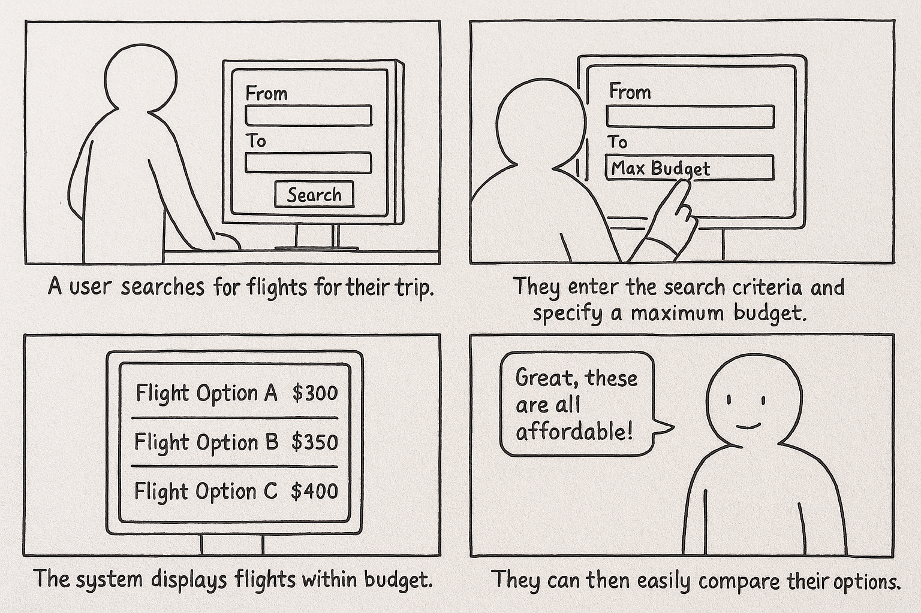

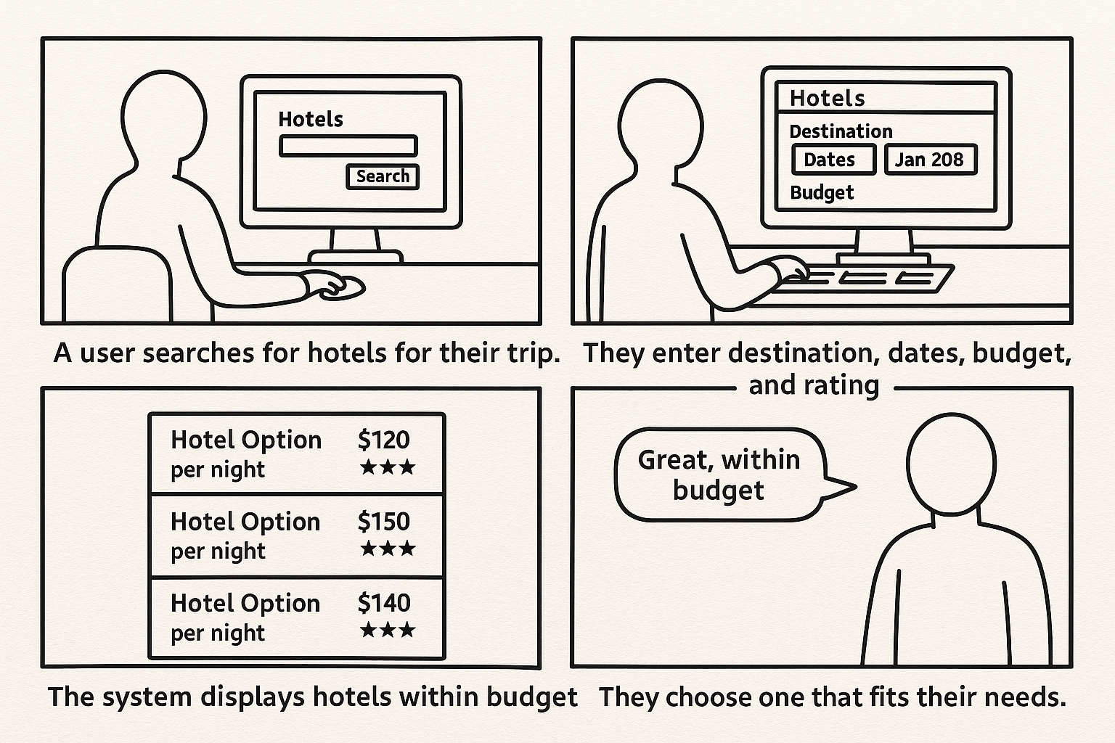

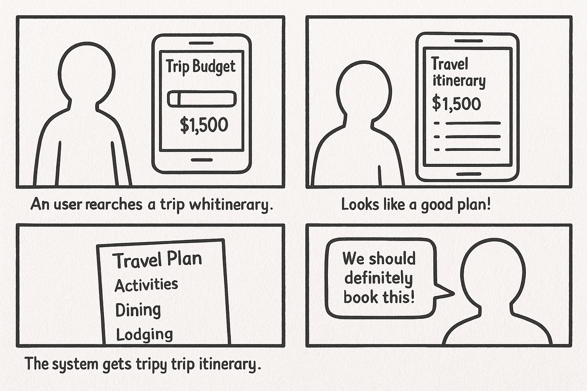

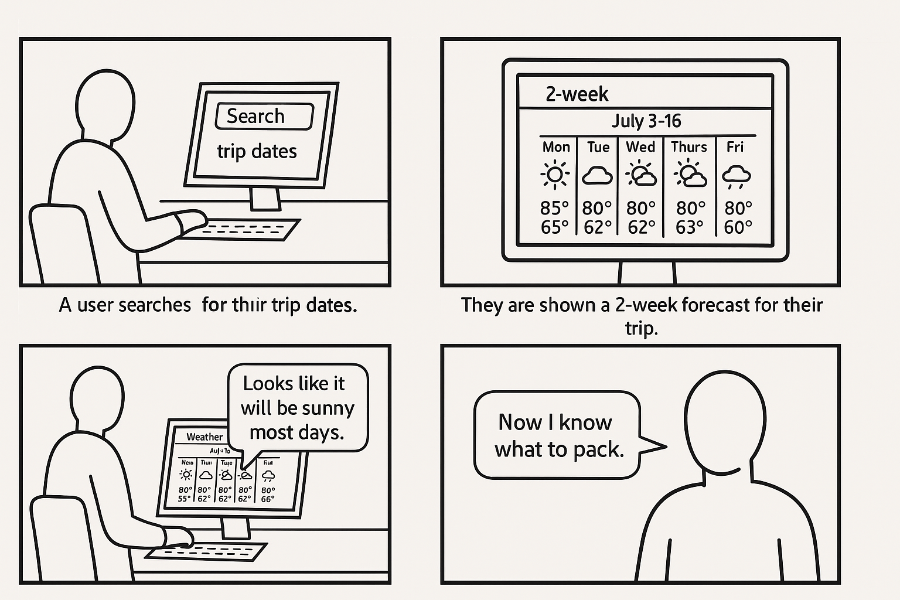

Part 4: GitHub Projects

<https://github.com/UCCS-CS4300-5300/Group-7-Fall-2025-Sec-2.git>